**TAKE A BREAK [ PYTHON APP USING KIVY MODULE]**

**PURPOSE:**

Anyone who is working professional/student who is continuously working with the computer system[laptop/desktop] daily would look out for an app which can offer systematic time out to take breaks. This App is made to achieve this goal.

**SYSTEM SUMMARY:**

Made with Python 3.7 using KIVY which supports Cross-platform Python Framework for UI Development.

**Overview:**

Once Take a Break App is run it opens to the below UI. User can control/configure/add to the play list and can view the queue using the UI options provided.

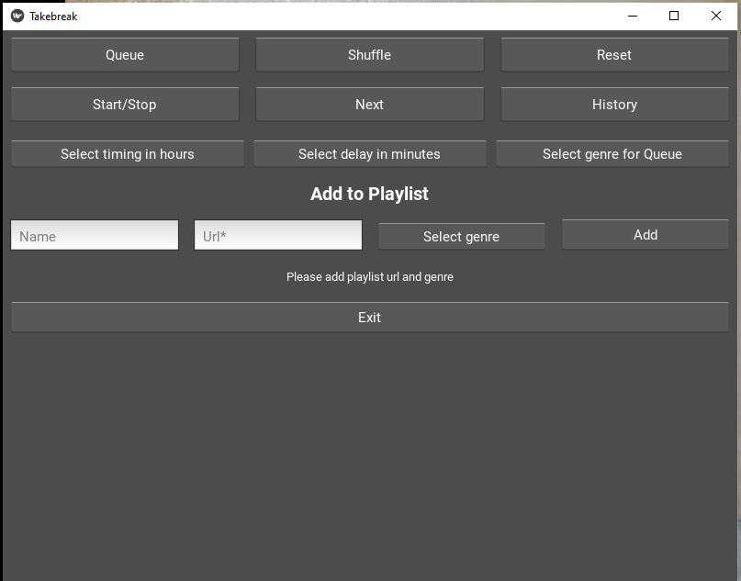

**Navigating the UI:** The user interface contains four main areas you will interact with: the Control Area, the Configure Area, the Add to Playlist Area and the Showcase of Queue.

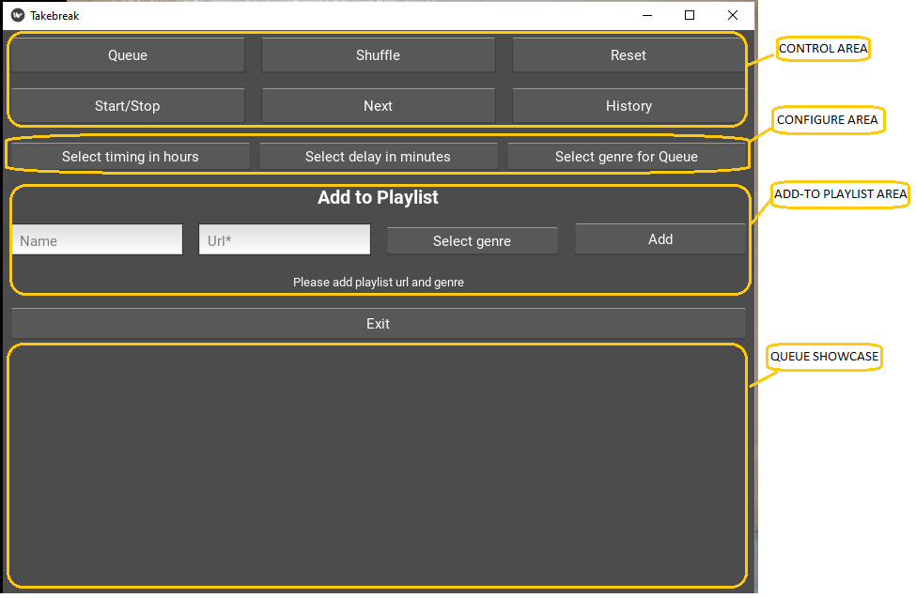

**Control Area:**



Displaying the playlist of the genre chosen. Queue shows the list of items as per the current selection of genre. For example, if it is selected to Videos then corresponding list of Videos will be shown.



Shuffles the Queued items randomly.



Resets or Clears the playlist.



Toggles between Start and stop of the Queued item.



Moves to the next item in the Queued item.



Shows the list of items that have been played earlier.

**Configure Area:**



Shows the default timing for which the Break has to be scheduled. User could change the timing to 2/4/6/8 hours as options.



Allows the user to start the break after certain amount of delay [30/60 mins ]



Allows the user to select Genre of his selection to be loaded into the playlist. Few options of Genre are Videos/Jokes/News/Learning, etc.

**Add to Play List Area:**

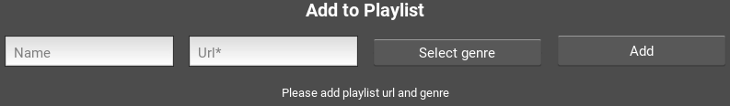

**Add to Play Listbutton Area opens options menu panel with the following features:**

1.Input Optional Playlist names and Genre based URLs / Youtube Channel URLs.

2.Select Genre to have the input URL to move into specific bucket/category.

3.Adding it into the repository, for later use.

**Showcase of Queue:**

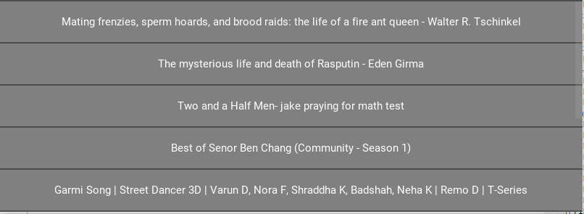

Showcase lists the Queue based on User’s Genre selection.

**System Requirements**

|  |  |
| --- | --- |
| Operating System | Windows 7 or higher |
| Processor | 1 GHz processor |
| Memory | 512 MB of RAM |
| Monitor Resolution | 1024 x 768 |
| Free Hard Disk Space | 5 GB of free disk space |
| Internet Connection | Broadband (high-speed) Internet connection with a consistent minimum speed of 1.5 Mbps. |
| Internet Browser | Microsoft Edge, Chrome or Firefox |